TÜRKİYE REPUBLIC
YILDIZ TECHNICAL UNIVERSITY
FACULTY OF CHEMICAL METALLURGY
DEPARTMENT OF MATHEMATICS ENGINEERING

PROBLEM SOLUTION TECHNIQUES INTERNSHIP

STUDENT’S
NAME SURNAME :………………………………………
NUMBER :………………………………………

TR

PHOTOGRAPH
It will be added digitally.

YILDIZ TECHNICAL UNIVERSITY
INTERNSHIPS BOOK

INTERNSHIP TYPE :
NAME AND SURNAME :
STUDENT NUMBER :

Name of Company | Department | Intership Interval |  | Work day
 |  | from Date | to Date

EVALUATION

Adaptation to the workplace Diligence Ability

The workplace supervisor who makes the evaluation evaluates the practical work result of the student according to the following criteria.

Excellent  Good  Fair  Adequate  Unsuccessful | A  B  C  D  TO

The contents of the internship book were examined and deemed appropriate.

…../…../….….

Authorized Supervisor
(Signature and Company Stamp)

Content Page

1. Introduction………………………………………….…………………………………….…….................3
2. Introduction of the Company………………....……..……………………………......................4
3. Introduction of the Department….……..……….…………………....................................5
4. Weekly Work Schedule………………….…………....…………………...…..............................6
5.Daily Work Reports………………………………………….……………………..............................8
6.Project: “Name of the Project”…………………………….…………………………………….........9
6.1 Introduction of the Project……….………………………….………..………………....... 9
6.2 Planning of the Project Process….………………………….…………....................10
6.3 Detailing of the Project…………………..……….……..…………........................... 11
6.4 Screenshots of the Project …………………………….…………………………….........12
6.5 Evaluation of the Project…….………………………………..…….………................. 13
7. Evaluation of the Internship…………………………………………………..………...................14
8. References….………………………………………………..……................................................15

SECTION | 1.INTRODUCTION |  |  |  | PAGE | 3
In this section, general and brief information about the internship should be given, and what is explained in the other parts of the internship report should be summarized. In this section, what is explained in which section of the report should be briefly included in this section.

INTERNSHIP  OFFICIALS | Title  Name and Surname |  | Company stamp  Authorized Signature
SECTION |  | 2. INTRODUCTION OF THE COMPANY |  |  |  | PAGE | 4
Information about the basic working area, organizational structure, production and products of the company should be given. While introducing the institution, the student should also make their own comments instead of copying and pasting the information on the web page as it is.

In this section, the Organization Chart of the company should take place in diagram form. The organizational chart is a diagram that clearly shows the departments, sub-departments and units of the company as a diagram. If the company does not want to share this chart, it is sufficient to take a signed and stamped petition stating that it cannot be shared with its excuse and it should be added to the internship report.
An example organizational chart is given below:
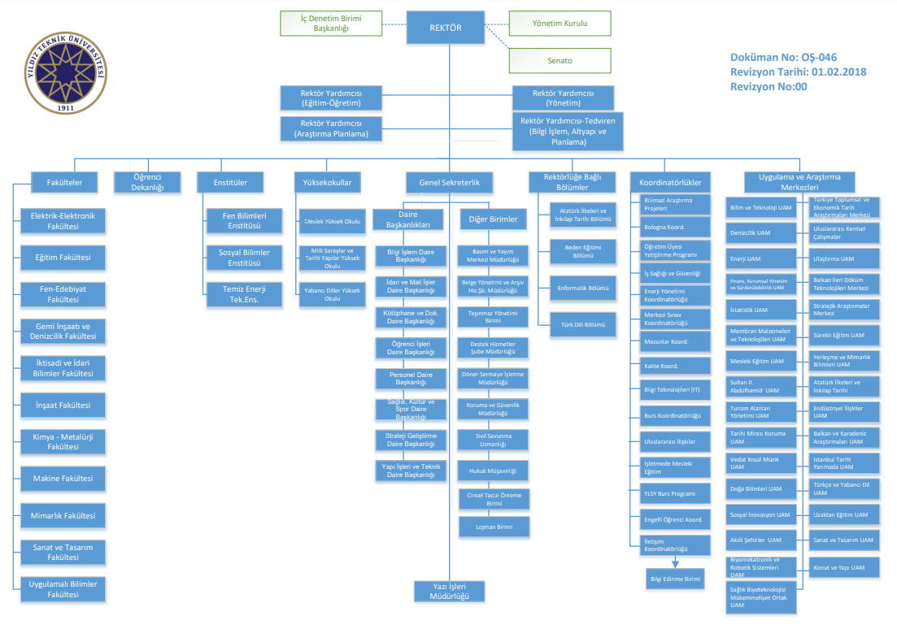

INTERNSHIP  OFFICIALS | Title  Name and surname |  |  | Company stamp  Authorized Signature

SECTION | 3. INTRODUCTION OF THE DEPARTMENT |  |  |  | PAGE | 5
Information about the special hardware and/or software of the internship department, if any, should be given, and the applications carried out in the department should be mentioned. The organizational structure of the department should also be summarized. Job descriptions of the employees in the organizational structure should also be given. This information should not be taken ready-made from an existing document, but should be obtained by questioning/observing the authorized person(s). If necessary, it will be useful to get information from the employees in the department, while giving job descriptions.

Workflow Diagrams should be included in this section. If the company does not want to share this diagram, it is sufficient to take a signed and stamped petition stating that it cannot be shared with its excuse and it should be added it to the internship report.
An example Workflow Diagram is given below:
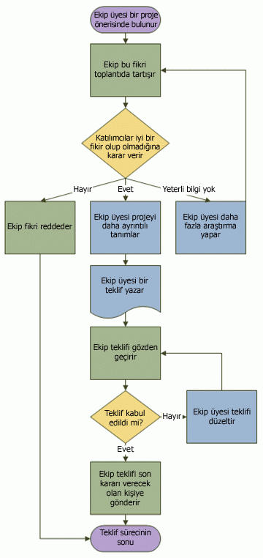

INTERNSHIP  OFFICIALS | Title  Name and surname |  | Company stamp  Authorized Signature

SECTION | 4. WEEKLY WORKING SCHEDULE |  |  |  |  | PAGE | 6
WORKING WEEK 1 |  | Starting Date | ........./........../...................
 |  | Ending Date | ........./........../...................
DAY | THE WORK DONE |  | PAGE NO
Monday
Tuesday
Wednesday
Thursday
Friday

WORKING WEEK 2 |  | Starting Date | ........./........../...................
 |  | Ending Date | ........./........../...................
DAY | THE WORK DONE |  | PAGE NO
Monday
Tuesday
Wednesday
Thursday
Friday

INTERNSHIP  OFFICIALS |  | Title  Name and surname |  | Company stamp  Authorized Signature

SECTION | 4. WEEKLY WORKING SCHEDULE |  |  |  |  | PAGE | 7
WORKING WEEK 3 |  | Starting Date | ........./........../...................
 |  | Ending Date | ........./........../...................
DAY | THE WORK DONE |  | PAGE NO
Monday
Tuesday
Wednesday
Thursday
Friday

WORKING WEEK 4 |  | Starting Date | ........./........../...................
 |  | Finishing Date | ........./........../...................
DAY | THE WORK DONE |  | PAGE NO
Monday
Tuesday
Wednesday
Thursday
Friday

INTERNSHIP  OFFICIALS |  | Title  Name and surname |  | Company stamp  Authorized Signature

SECTION |  | 5. DAILY WORKING REPORTS |  |  |  | PAGE | 8
The work done during the internship, the learned systems and products, the undertaken projects and the performed practices should be reported on a daily basis using this template.

Instead of copying and pasting the theoretical information from a source as it is, comments such as the summary of the learned concepts and their benefits to the study and the added value it provides to the student should be represented.

A sample daily working report is given below for three days:

05.07.2021
Information about the institution, such as the basic field of work, organizational structure, production and products, was obtained. Headquarters and branches of the company were visited and examined. During these trips, the place and importance of the computer in the company were also examined. This information is explained in detail in the second part of the internship report.

06.07.2021
The employees in the internship department were met and their tasks were learned. An organizational chart has been created. The responsibilities and working styles of the employees were examined. In addition, the hardware and software infrastructure of the department was also analyzed. This information is explained in detail in the 6th section of the internship report.

07.07.2021
The project on which the IT deparment was working was examined. The tasks and responsibilities of everyone in the project team were examined. The structure was learned by examining the analysis and design diagrams of the modules of the project. The general structure of the project is given in Table 1. The project manager gave information about the module that he wanted to be carried out during the internship. He provided the necessary resource books and internet addresses. These resources have been examined. In the light of the explanations of the project manager, a list of subjects to be learned and a work plan were prepared.

INTERNSHIP  OFFICIALS | Title  Name and surname |  |  | Company stamp  Authorized Signature

SECTION |  | 6.PROJECT: “Name of the Project” |  |  |  | PAGE | 9
SUB-SECTION |  | 6.1 Introduction of the Project
The project carried out during the internship should be introduced basically. If a certain part of a large project has been assigned, the main project should be firstly introduced, and then the student's own part of the project should be described.
The purpose of the project should be explained clearly and in detail. Programming language, query language, etc., which are used in the Project, should be specified and explained in a few sentences.

INTERNSHIP  OFFICIALS | Title  Name and surname |  |  | Company stamp  Authorized Signature

SECTION |  | 6. PROJECT: “Name of the Project” |  |  |  | PAGE | 10
SUB-SECTION |  | 6.2 Planning of the Project Process
Before the start of the project, the planned creation process of the project should be given in item by item.

INTERNSHIP  OFFICIALS | Title  Name and surname |  |  | Company stamp  Authorized Signature

SECTION |  | 6. PROJECT: “Name of the Project” |  |  |  | PAGE | 11th
SUB-SECTION |  | 6.3 Detailing of the Project
The details of the project will be explained, taking into account the plan which is given the previous sub-section.

INTERNSHIP  OFFICIALS | Title  Name and surname |  |  | Company stamp  Authorized Signature
SECTION |  | 6. PROJECT: “Name of the Project” |  |  |  | PAGE | 12
SUB-SECTION |  | 6.4 Screenshots of the Project
Screen outputs/images detailing the work that was obtained/done as a result of the project's work; should be included comprehensibly along with all necessary explanations.

INTERNSHIP  OFFICIALS | Title  Name and surname |  |  | Company stamp  Authorized Signature

SECTION |  | 6. PROJECT: “Name of the Project” |  |  |  | PAGE | 13
SUB-SECTION |  | 6.4 Evaluation of the Project
In this section, the project will be evaluated in detail. The success rate, negative and positive aspects of the project should be presented according to the objectives determined at the beginning. The difficulties encountered in the project should be stated. It should be interpreted how the project can be developed in the future.

INTERNSHIP  OFFICIALS | Title  Name and surname |  |  | Company stamp  Authorized Signature

SECTION | 7. EVALUATION OF THE INTERNSHIP |  |  |  | PAGE | 14
The knowledge and experience accomplished by the internship should be explained, and the results (problem, observation, comment, etc.) of the project or the contributed parts of the practice should be summarized. Observations including the problems encountered during the internship and/or observed in the company and the solutions produced to these problems or produced by the company should be reported.
A good evaluation section should be at least one page in size, as it covers the entire internship work.

INTERNSHIP  OFFICIALS | Title  Name and surname |  | Company stamp  Authorized Signature

SECTION | 8. REFERENCES |  |  |  | PAGE | 15
The resources (books, articles, journals, web pages, lecture notes, etc.) used in the research and study during the internship period should be listed in this section. Any quotation not cited in this section should not be used in the internship report.
Necessary action will be taken against the student when any citation in the internship report is quoted without reference in this section, and when it is determined by the commission in the internship report evaluation.

INTERNSHIP  OFFICIALS | Title  Name and surname |  | Company stamp  Authorized Signature

